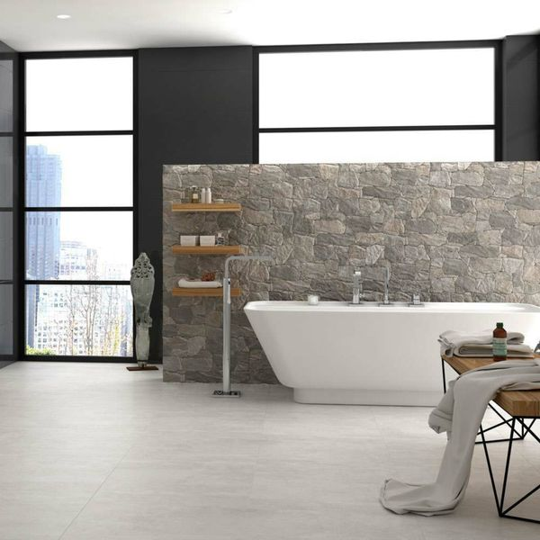**Stacked Iron Stone:**

## **Product Description**

Warm-up your interior spaces with these stylish Stacked Iron Stone Effect Tiles. Made from porcelain, their stone effect design allows you to create the illusion of a stacked stone wall, like you might find in a traditional cottage, in your home. They are beige in colour and have a matt finish. Try before you buy by ordering a sample tile. They're suitable for use in both internal and external wall spaces.

## **Product Info**

* Product ID: 29160
* Tiles Per SQM: 4.6200046200046
* Sale by: Per SQM
* Size: 650x333x10mm
* Weight: 3.93 KG
* Material Type: Porcelain
* Finish: Matt
* Colour: Beige/Ivory
* Suitability: Walls
* Grade: 4
* Rectified Edge: No
* Underfloor Heating: No
* Thickness (mm): 10